Green Oak Ranch Camp Information Sheet

TELEPHONE Campers will not be called to the telephone or allowed to call out except in an emergency.
The emergency camp number is:
1-760-727-0251 ext. 307
Please use this number for family emergencies only! This is a 24 hour line answered by Green Oak Ranch staff.
If voice mail picks up (means phone is in use), leave a message with the following information:

Name of Camp Group (LAGC)
Name of camper (first & last name)
Emergency message
Return phone number (with area code)

VISITORS Visiting the camp or campers is not permitted unless previously arranged.

MAIL Address all mail to:
Green Oak Ranch
1237 Green Oak Road
Vista, CA 92081
Attention: (Camper’s Name, Name of group, & Cabin #)

Campers love mail!! So, please, mail letters early so he/she can receive mail at the beginning of the week. Your last letter should be mailed on Wednesday to be received by Friday. Please send pre-addressed postcards or envelopes with stamps for your child to write home.

PACKING All baggage and clothing should be clearly marked with camper’s full name. We suggest that you pack with your child present and make a written list of articles packed to help both counselor and camper keep track of what he/she brought. Please enclose your list in your camper’s baggage.

MEDICATION All medications that your child is required to take to camp MUST BE IN THE ORIGINAL PHARMACY LABELED CONTAINER clearly stating all prescription information (name of medication, dosage, how & when to be given, etc.). DO NOT PACK MEDICATIONS!! Medication will be given to the camp nurse at July 27 pre-check & lice inspection (9am-11am), or when checking in at camp by the parent/guardian or other responsible adult. Please put medications with instructions in a Ziplock bag with your child’s name on it to help the nurse keep medications separate.

TRANSPORTATION Just a reminder: we are asking families to drive their campers to and from camp in order to keep the camp cost low, provide safe transportation and to have a family fun day.

CAMP CHECK-IN (this will include a head lice check if your child did not attend the pre-check on 7/27)

Sunday, July 28 - 3:30pm to 5:00pm (no earlier!)
Pick-up time on Saturday, August 3 at 9:30AM – Chapel is at 8:30AM if you would like to participate.

If you are not picking your child up we need to have the name and phone number of the person who is on a 3x5 card turned in at the registration table. Please make sure that person knows to pick up by 9:30am. Thank you.
(If you wish to pick your camper up earlier please let the directors know so we can be sure that he/she is ready.)
The driving time from the Long Beach area is 1 ½ hours.
Camp starts at 5:00pm Please be on time!
Please, NO spending money!!

Transportation
T
o help keep the cost of camp low, to provide safe transportation to the camp, and to involve the whole family in a fun day, families will get to drive their campers to the camp along the 5 fwy and 15 minutes down the 78 fwy. You will get to check your campers into their cabins, meet their counselors and preview the camp. Check-in begins at 3:30pm on Sunday July 29.

Families are to pick-up their campers NO LATER THAN 9:30am on
Saturday, August 4. You are welcome to join us for chapel at 8:30AM.
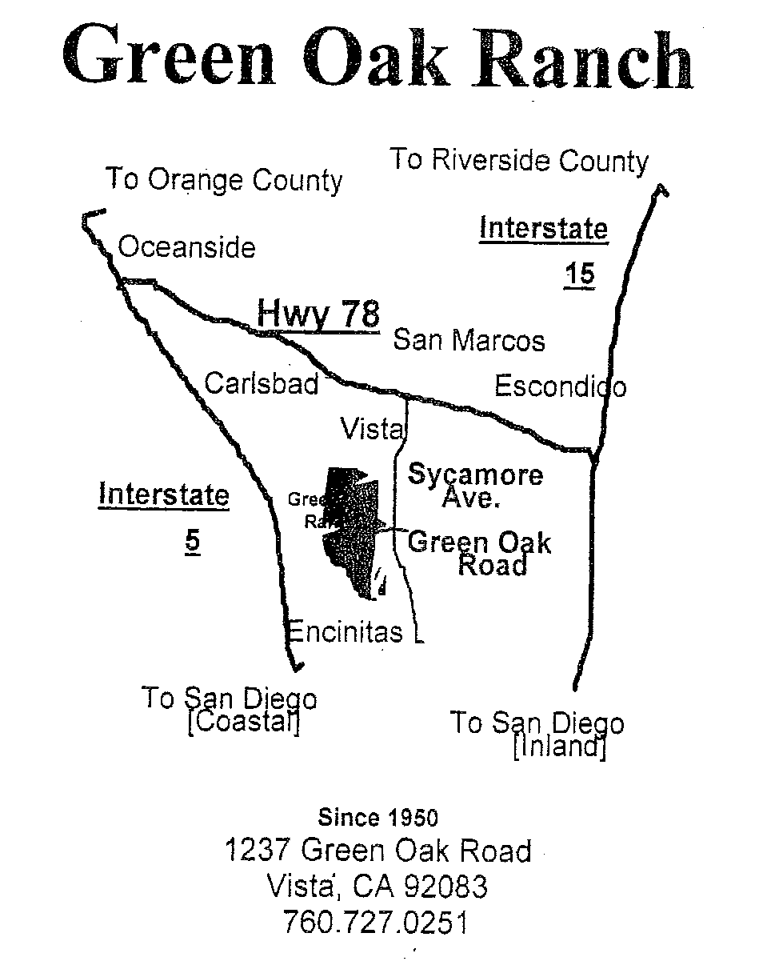
Since 1950
1237 Green Oak Road
Vista, CA 92081
1-760-727-0251 ext. 307

