Green Oak Ranch Packing List
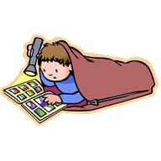
This is a guide for your camper. You don’t have to purchase new clothing for camp unless you have nothing on hand that would be serviceable. Camp is a good place to wear out old clothing!
Clothing Bedding
1 pair long pants sleeping bag
4 pair shorts (& 1 pair that can have paint spatter on them) blanket
2 long sleeved shirts pillow
5 t-shirts or short-sleeved shirts sheets (optional)
9 pair underwear (or more) + 9 pair socks
1 swimsuit Other Items
1 pair each: tennis shoes, flip flops, water shoes,
& sandals (for shower only) Bible (important)
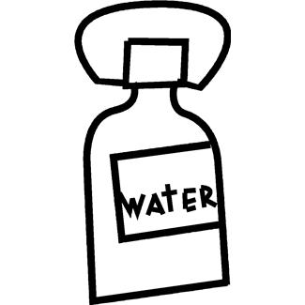
1 sweatshirt or light jacket flashlight (important)
1 beach towel pencils/paper
books (optional)
hat (important)
suntan lotion/sunscreen
Toiletries beach towel
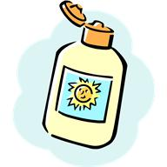
soap (in container) bug spray
comb/brush water bottle
toothbrush/toothpaste pre-addressed stationary/stamps
bath towel pool googles
laundry bag
Chapstick w/sun block
washcloth
shampoo
5 Band-aids Please put your name on all items!!
all medications (including vitamins, cough drops, etc.)
Must be in the original pharmacy labeled container &
Turned in to nurse.

Do Not Bring
Comic books, sports equipment, radios, any kind of knives, firearms (no air soft guns), matches, candy, gum, snacks, electronic games, cell phones, ipods, DVD players, ipads, laptops, etc.

Please do not bring gum or candy!
Or anything of value!

Packing Instructions
All personal clothing and equipment must be plainly marked with the camper’s name and packed in a suitcase or duffle bag. Attach a baggage tag to ALL bags. The church cannot assume responsibility for lost clothing or broken equipment.

We would like to suggest that you pack each days outfit (i.e. shirt, shorts, socks, underwear) in a Ziplock bag of which the camper takes out his/her clean clothes for the day and puts back his/her dirty clothes in the bag. It will make dressing easier and items will not get lost.

Please Note: It is easier for the child to work with a large suitcase, not an overstuffed small case. Also, please have your child help pack the suitcase so they know what they have.

PS: One activity will involve paint & mud – please send an old T-shirt or a white shirt for your child to wear.

